**In the spirit of “Sharing is Caring” – Thank you Microsoft 365 & SharePoint Community (PnP) team!**

# HOW TO: Create Quick Links spfx web part (using React) that provides easy sorting and CRUD operations.

**NOTE:** This document assumes that you have your spfx development environment setup.   
  
If not, head over to this article for details on how to set it up:  
<https://docs.microsoft.com/en-us/sharepoint/dev/spfx/set-up-your-development-environment>

1. Run **yo @microsoft/sharepoint** in the solution folder in VS Code terminal, and follow the responses shown below to each prompt.

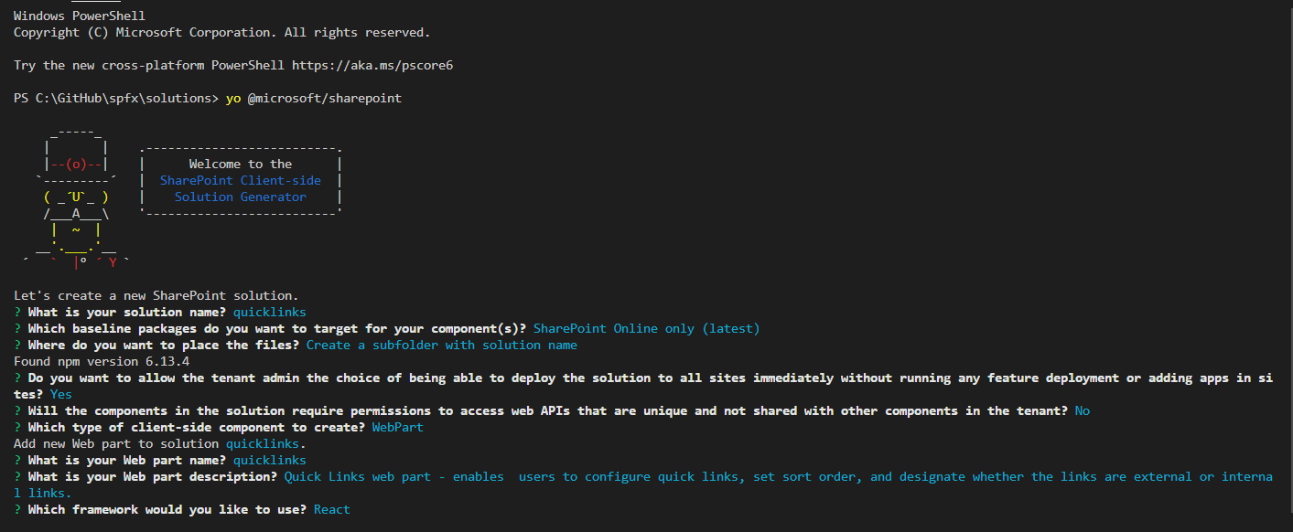  
  
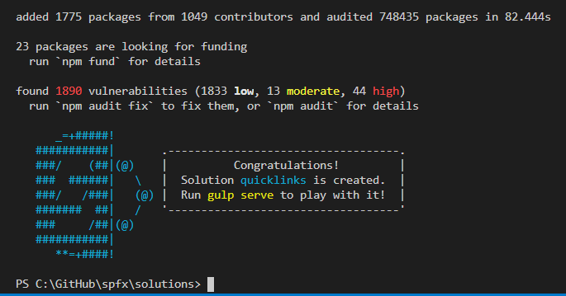

1. We are going to use the **PropertyFieldCollectionData** PnP spfx control in this web part. A few things to note about this control:

* This property field control gives you the ability to insert a list / collection data which can be used in your web part.
* Enables you to control the sort order of the items in the list / collection.
* In addition to adding an item, this control gives you the ability to update an existing item or remove an existing item from the list / collection.
* Ensure that you have installed the **@pnp/spfx-property-controls** dependency. Run this command in the Terminal session of the solution folder to install it.  
  *npm install @pnp/spfx-property-controls --save --save-exact*  
  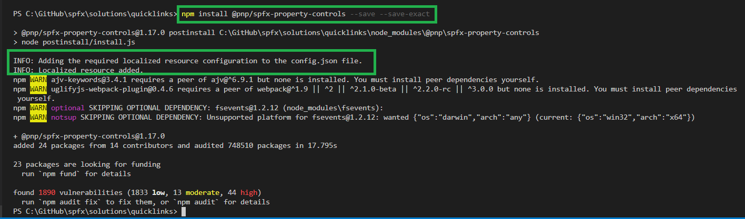  
    
  **NOTE**: The above command also adds this entry to the **config/onfig.json** file.  
  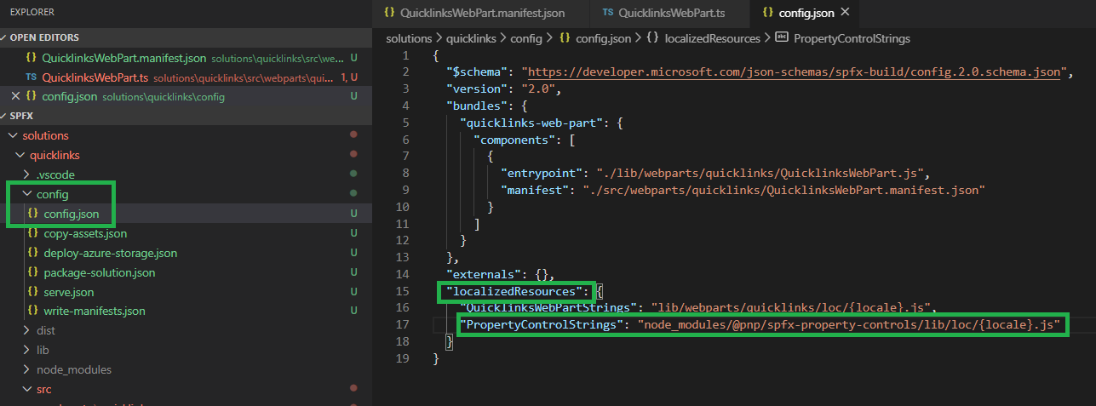
* For more details on the PropertyFieldCollectionData type , visit the page below:  
  <https://sharepoint.github.io/sp-dev-fx-property-controls/controls/PropertyFieldCollectionData/>

1. Open the **QuickLinksWebPart.manifest.json** and set the **title, description, officeFabricIconFontName** for the web part.   
     
   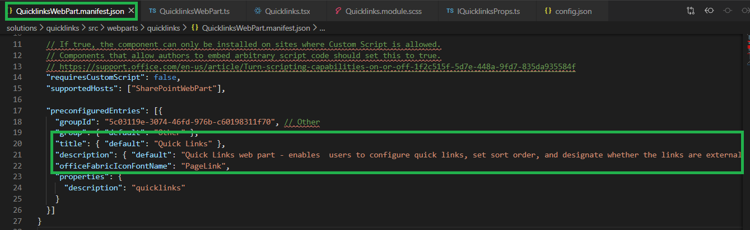

Here is the link to Office UI Fabric Icons page: <https://uifabricicons.azurewebsites.net/>  
  
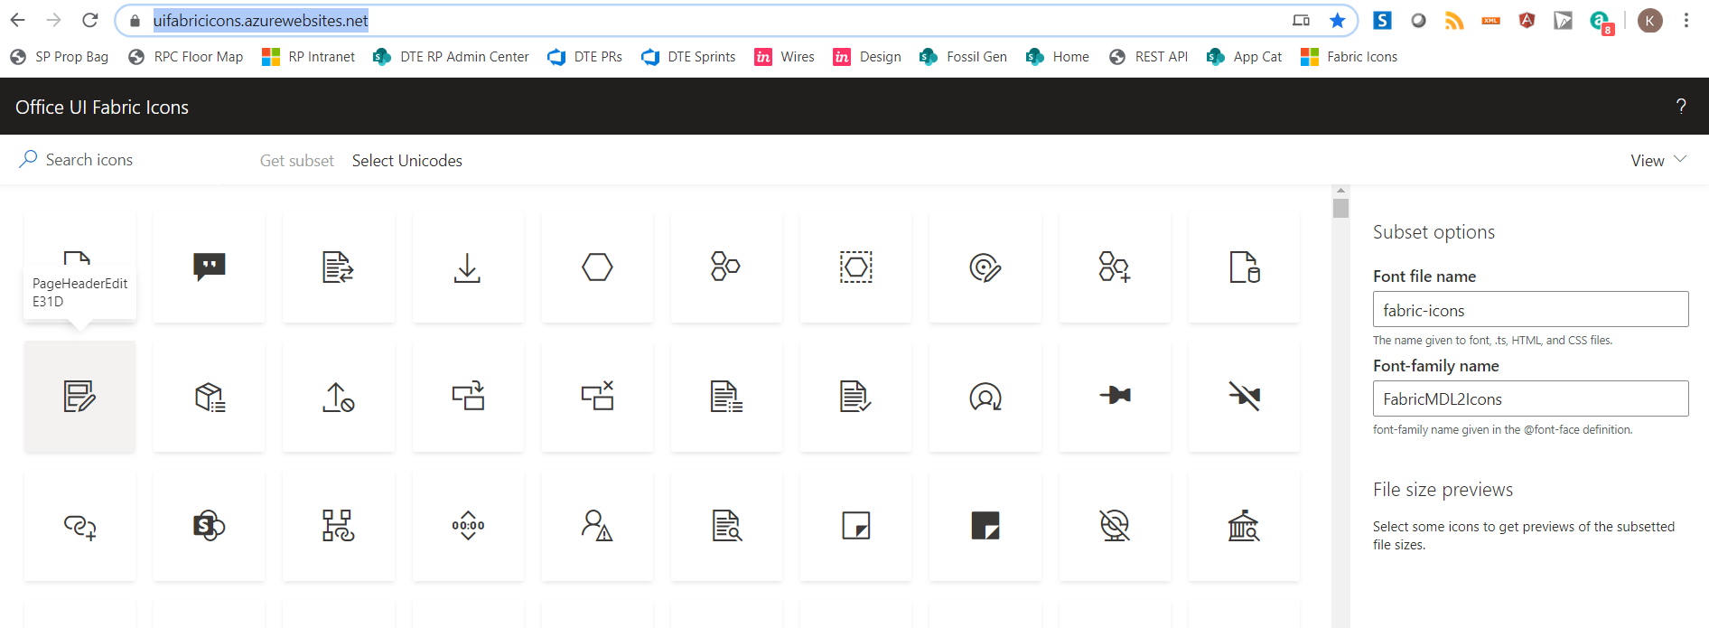

1. Open the **QuickLinksWebPart.ts** file and do the following:

* Add the following statement to import the **PropertyFieldCollectionData** module:

**import { PropertyFieldCollectionData, CustomCollectionFieldType } from '@pnp/spfx-property-controls/lib/PropertyFieldCollectionData';**

It should look like this:  
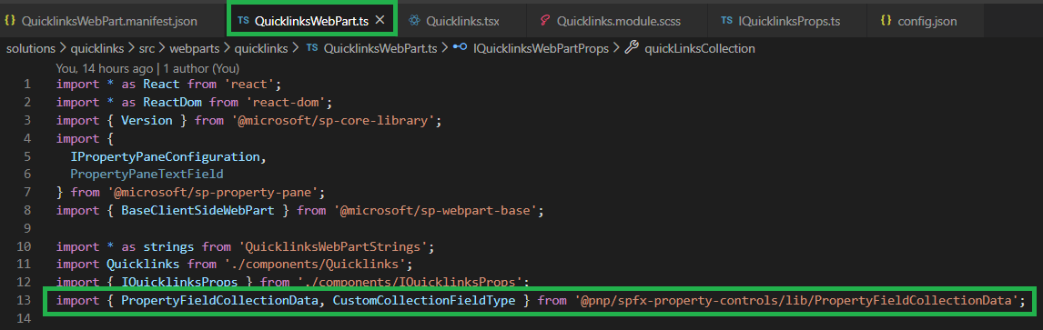

* Replace the **groupFields: []** section with the snippet shown below. It is a PropertyFieldCollectionData type.  
    
  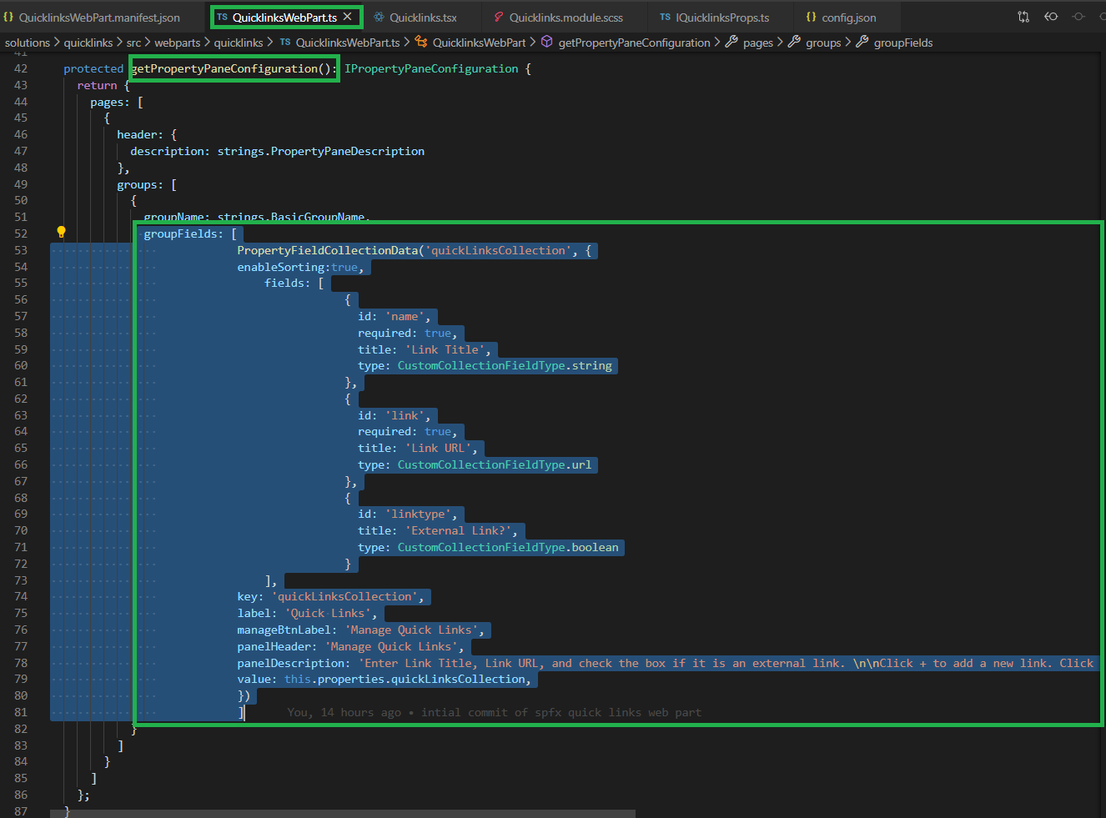

**PropertyFieldCollectionData code snippet**

* **enableSorting** is set to **true** – this creates the number column which allows you to sort items in the collection. The number column appears after you add the 1st item in the collection.
* **name** field is used to store the name of the link. It is of type **string.**
* **link** field us used to store the URL. It is of type **url.**
* **linktype** field is used to denote if the link is an external link. It is of type **boolean.**

|  |
| --- |
| groupFields: [                PropertyFieldCollectionData('quickLinksCollection', {                enableSorting:true,                    fields: [                                {                                  id: 'name',                                  required: true,                                  title: 'Link Title',                                  type: CustomCollectionFieldType.string                                },                                {                                  id: 'link',                                  required: true,                                  title: 'Link URL',                                  type: CustomCollectionFieldType.url                                },                                {                                  id: 'linktype',                                  title: 'External Link?',                                  type: CustomCollectionFieldType.boolean                                }                    ],                key: 'quickLinksCollection',                label: 'Quick Links',                manageBtnLabel: 'Manage Quick Links',                panelHeader: 'Manage Quick Links',                panelDescription: 'Enter Link Title, Link URL, and check the box if it is an external link. \n\nClick + to add a new link. Click x to remove link. \n\nSort order can be changed by selecting the number from the dropdown list in the first column below.',                value: this.properties.quickLinksCollection,                })                ]  } |

1. Open the **QuickLinks.tsx** file and add the code shown below and save the file.  
     
   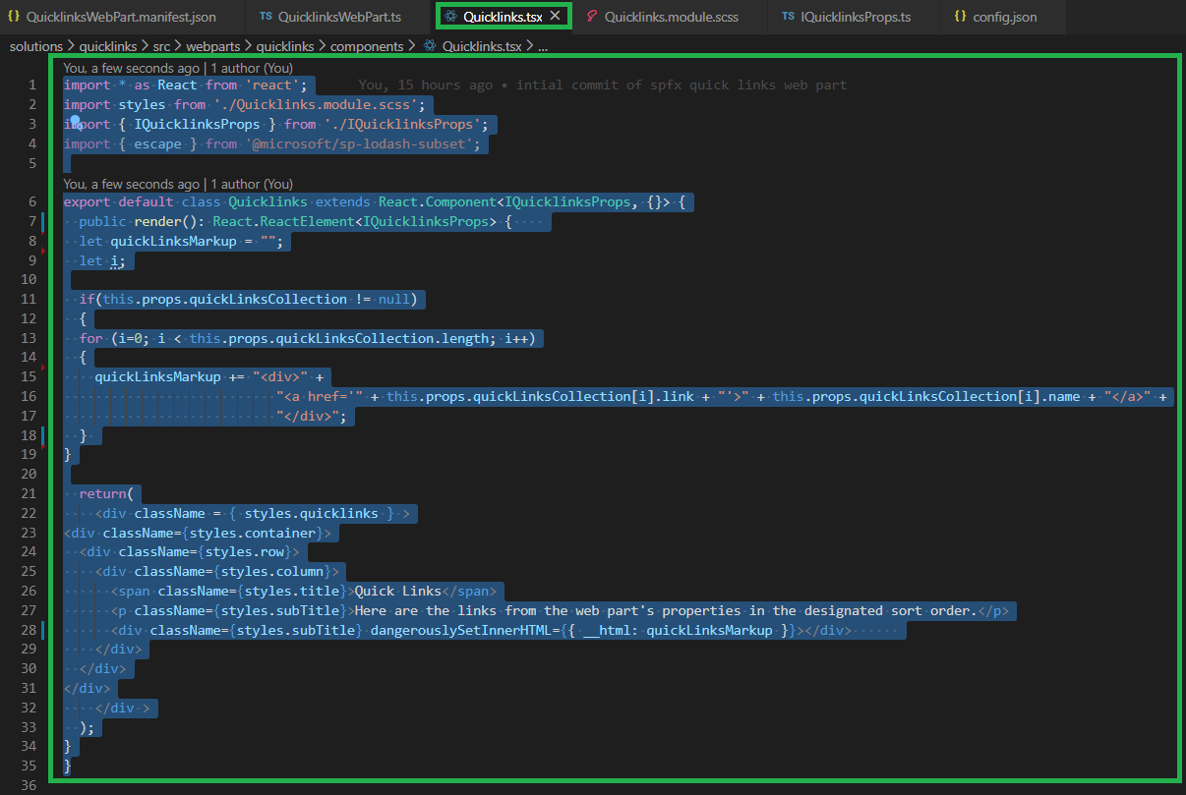

|  |
| --- |
| import * as React from 'react';  import styles from './Quicklinks.module.scss';  import { IQuicklinksProps } from './IQuicklinksProps';  import { escape } from '@microsoft/sp-lodash-subset';  export default class Quicklinks extends React.Component<IQuicklinksProps, {}> {    public render(): React.ReactElement<IQuicklinksProps> {    let quickLinksMarkup = "";    let i;    if(this.props.quickLinksCollection != null)    {    for (i=0; i < this.props.quickLinksCollection.length; i++)    {      quickLinksMarkup += "<div>" +                             "<a href='" + this.props.quickLinksCollection[i].link + "'>" + this.props.quickLinksCollection[i].name + "</a>" +                             "</div>";    }  }    return(      <div className = { styles.quicklinks } >  <div className={styles.container}>    <div className={styles.row}>      <div className={styles.column}>        <span className={styles.title}>Quick Links</span>        <p className={styles.subTitle}>Here are the links from the web part's properties in the designated sort order.</p>        <div className={styles.subTitle} dangerouslySetInnerHTML={{ __html: quickLinksMarkup }}></div>      </div>    </div>  </div>      </div >    );  }  } |

1. Run **gulp serve** from the solution folder as shown below:

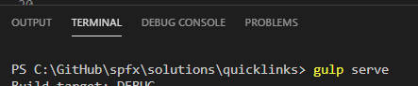  
  
The SharePoint Workbench will be launched, and you can then add the **Quick Links** web part to the page.

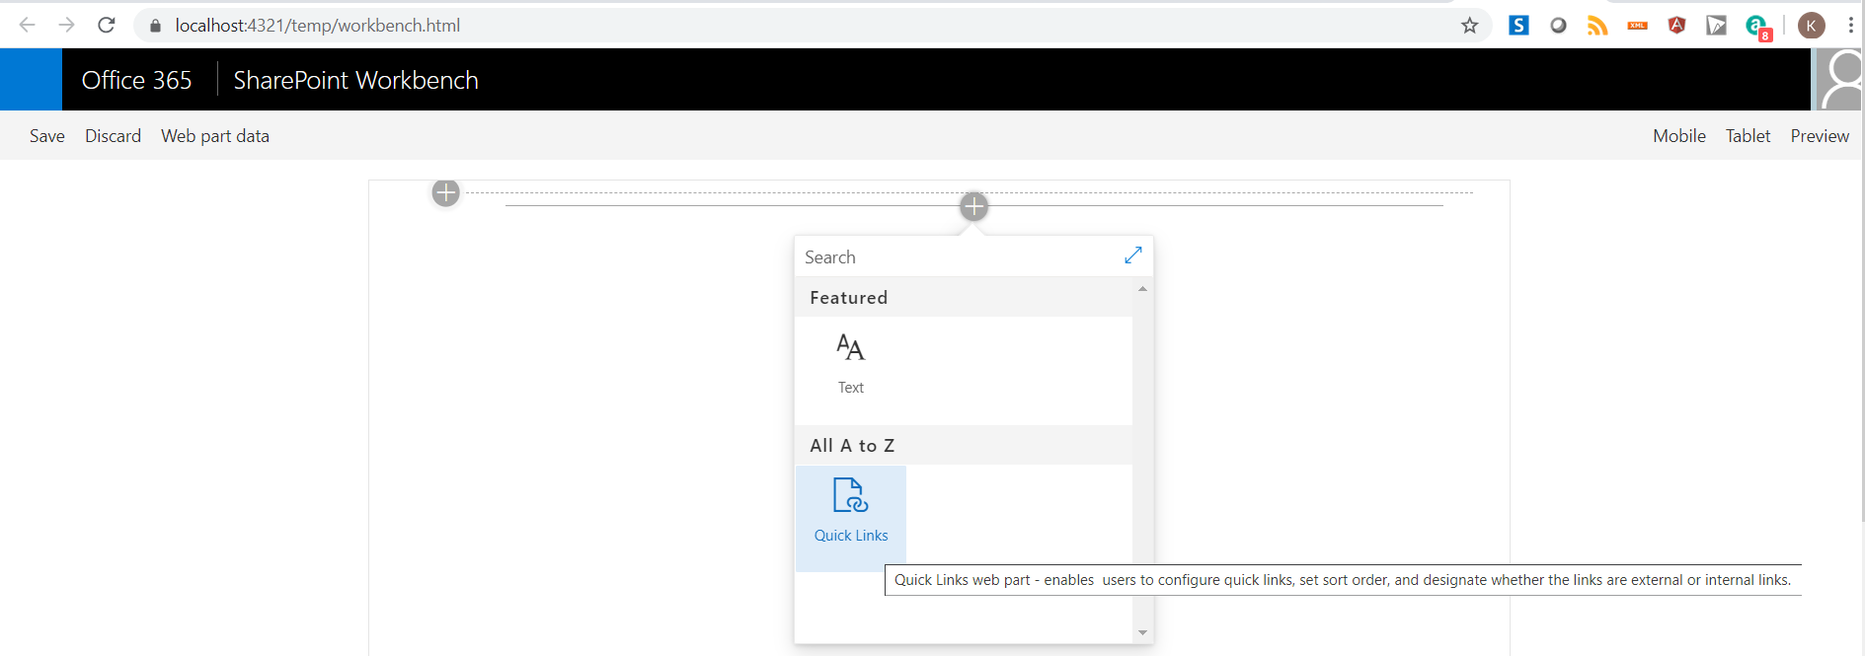

1. Add the **Quick Links** web part to the page, edit the web part, and click on the **Manage Quick Links** button in the property pane.  
     
   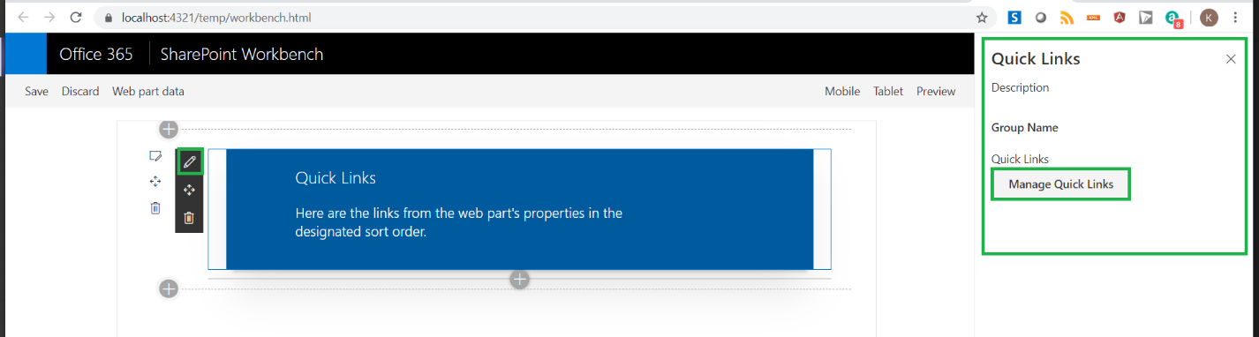  
     
   The following window will be displayed, where you can add/delete/update and set sort order of links.  
     
   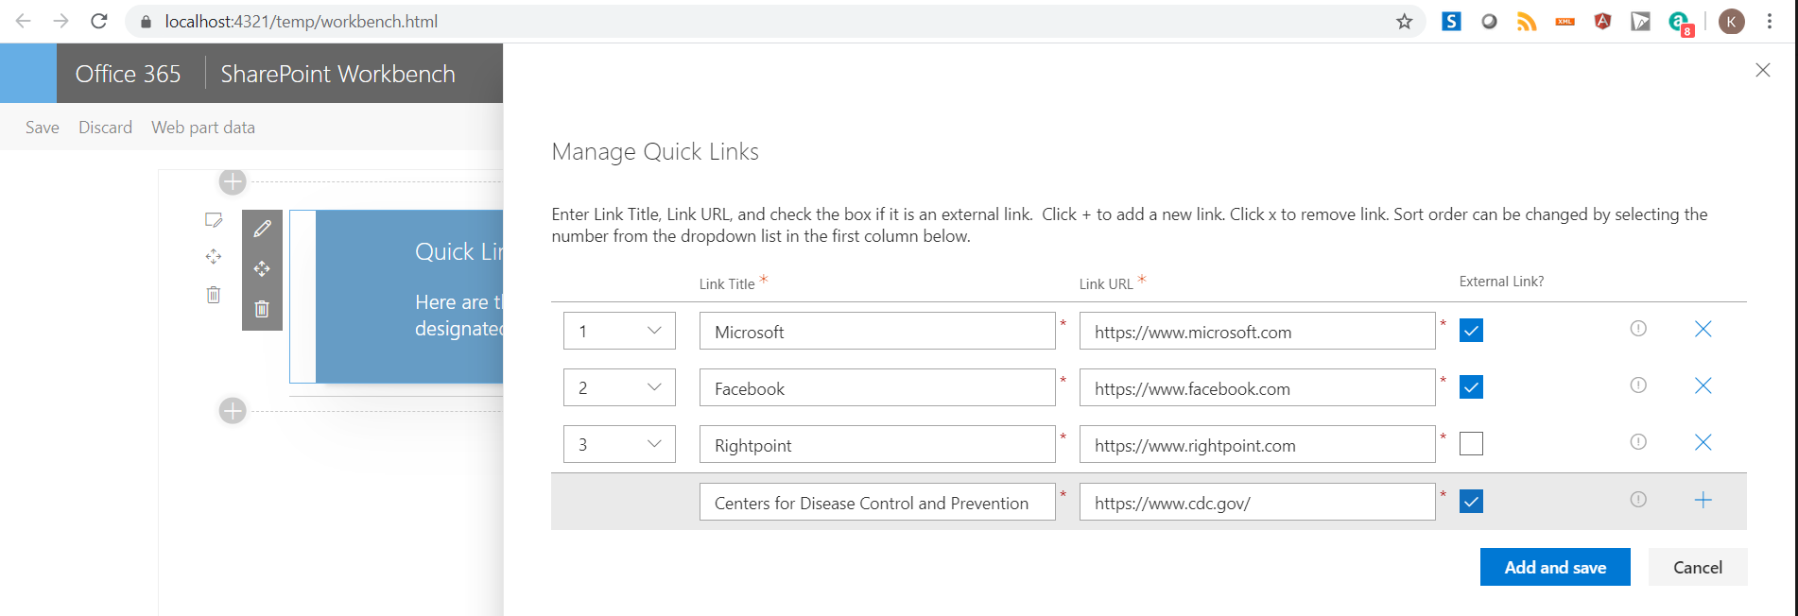

And the links are now displayed in the web part in the designated sort order:  
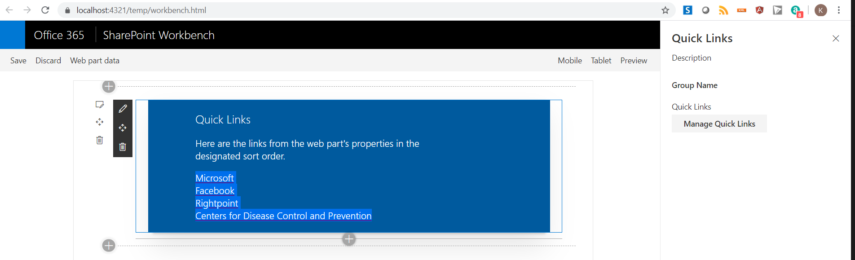

SharePoint does have a Quick Links web part, that allows you to add links and then drag and drop the links to arrange them in a specific order. The above custom Quick Links web part offers another mechanism to sort the links and enables CRUD operations within the web part property pane. Enjoy!